Computer Program Walk Through
- Team Roster Sheet will be sent to you from teams attending your meet. You will then cut and paste each teams’ entries from each team roster to the next sheet call the Entry Form
You will use the Mandatory Regional Meet Team Roster sheet found on MHSPLA.com website: https://www.mhspla.com/resources.

Team Roster Sheet
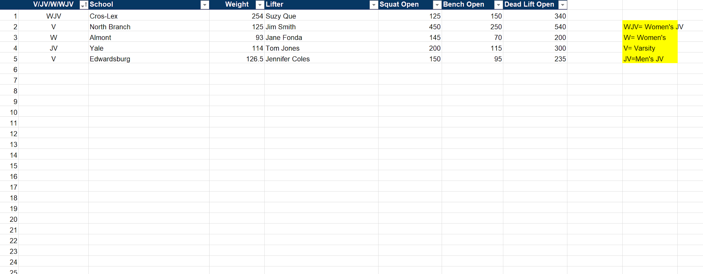

Entry Sheet
- Entry Sheet:

DO NOT TYPE IN THIS RED AREA

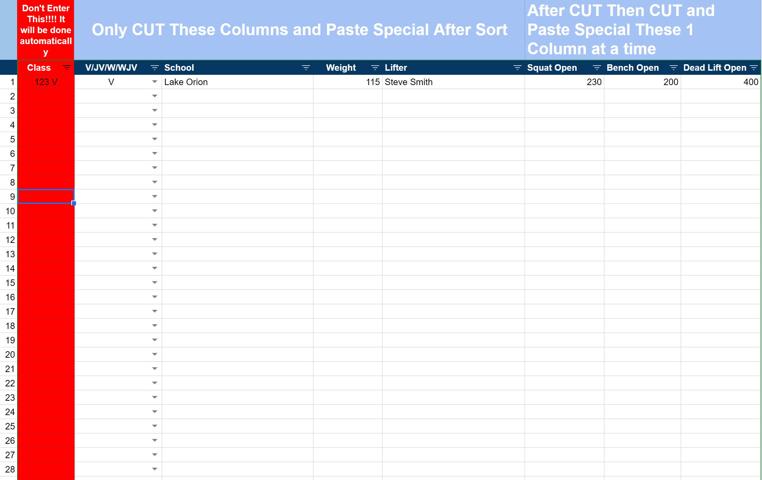

- Copy the following columns (Division, School, Weight, Lifter) first to the next tab Entry Form as seen below. Then copy and paste the following columns one at time (Squat, Bench, Deadlift) to the Entry Form
- Then you will see your totals populate on the right
Then you will be able to assign them platforms when you
have all lifters copied to this form.

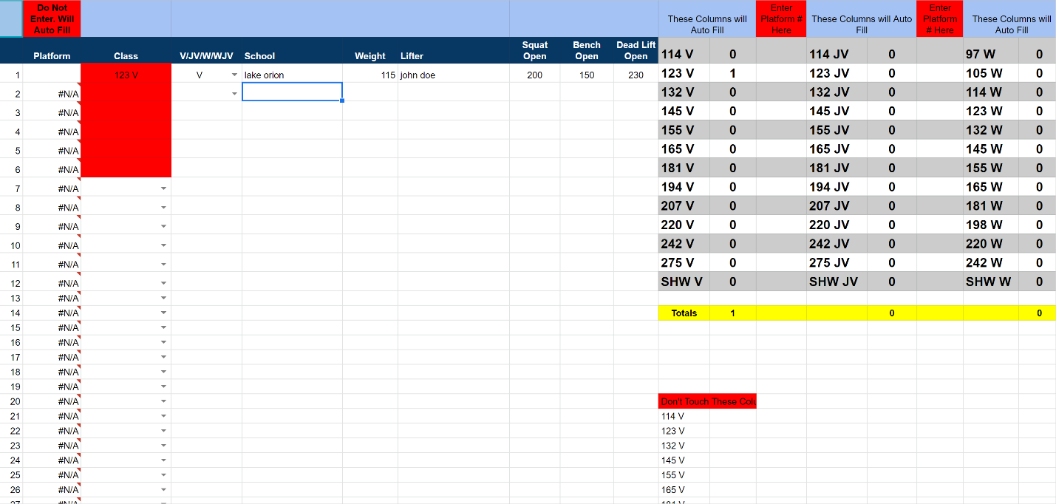

- Then you will use the copy & paste form. IT will automatically populate when you have everyone added to the entry form Sheet

Copy & Paste Sheet
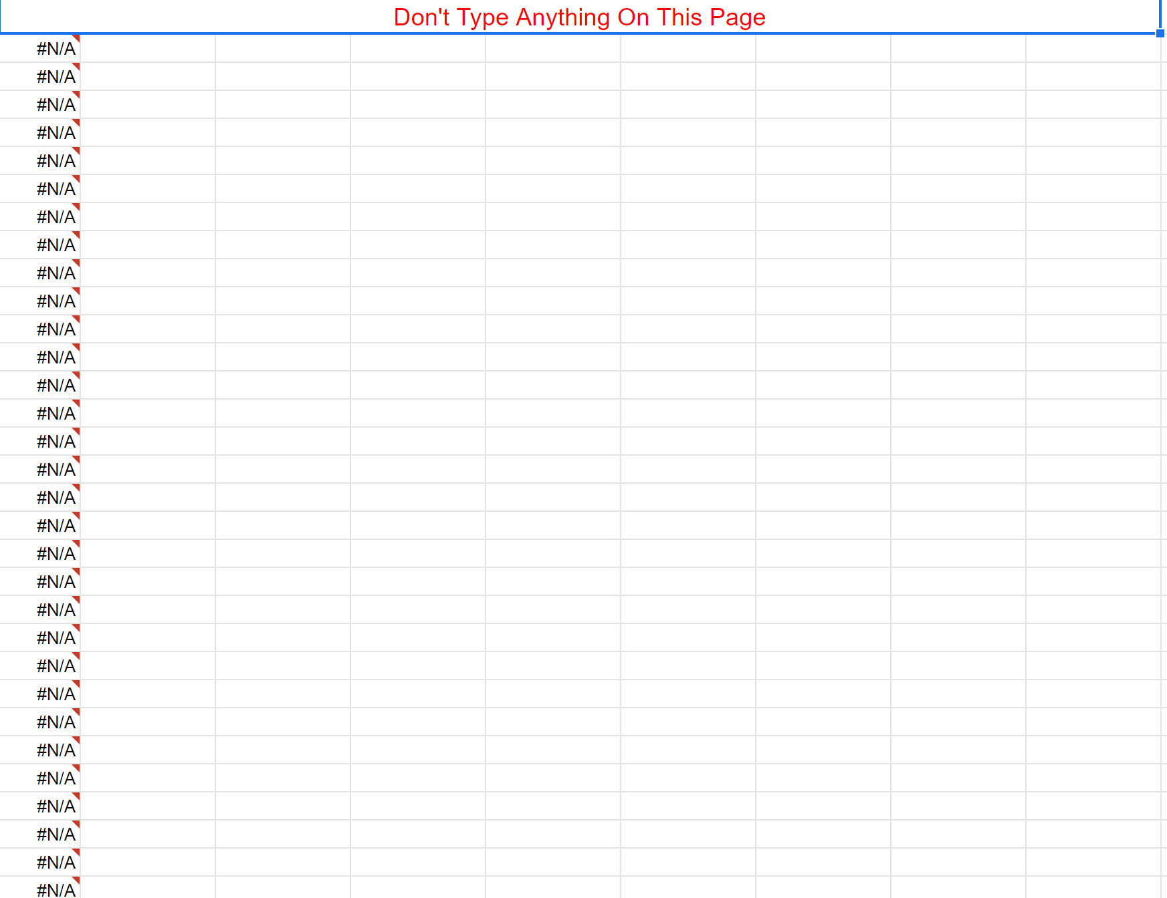

You will use this data to create lifter cards with Autocrat google sheets addon tool.
The following link is to a tutorial on how to use autocrat:
https://youtu.be/SkpY2ODnncA

You will use the following files with autocrat:
PLATFROM LIFTERCARD SORT SHEET
https://docs.google.com/spreadsheets/d/1F9Mc70jYW_-Lb0Vrti_AK-EOksuZPox8JiyRp_TjVR8/edit?usp=sharing

2019-2020 Template Regional Platform Cards
https://docs.google.com/document/d/1nn_3J2nJkNTrltmT0tfoq--w2A0rUQZTOFnNTgKdKZg/edit?usp=sharing

